3.91: In a time 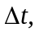 the velocity vector has moved through an angle (in radians) 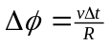 (see Figure 3.23). By considering the isosceles triangle formed by the two velocity vectors, the magnitude 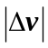 is seen to be 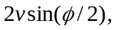 so that
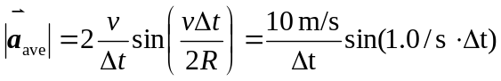
Using the given values gives magnitudes of 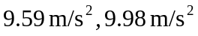 and 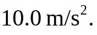 The instantaneous acceleration magnitude, is indeed approached in the limit at 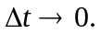 The changes in direction of the velocity vectors are given by 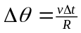 and are, respectively, 1.0 rad, 0.2 rad, and 0.1 rad. Therefore, the angle of the average acceleration vector with the original velocity vector is and 